Class Activity: 10.07.2026

Scenario 1: Student Academic Performance Dashboard
Code:
import pandas as pd
import matplotlib.pyplot as plt
data = {
"Student ID": [101,102,103,104,105,106,107,108],
"Attendance": [95,80,88,70,92,85,75,98],
"Internal Marks": [90,75,82,68,94,80,72,97],
"Department": ["CSE","AI","IT","ECE","CSE","AI","IT","ECE"]
}
df = pd.DataFrame(data)
colors = {
"CSE": "blue",
"AI": "green",
"IT": "orange",
"ECE": "red"
}
plt.figure(figsize=(8,6))
for dept in df["Department"].unique():
dept_data = df[df["Department"] == dept]
plt.scatter(
dept_data["Attendance"],
dept_data["Internal Marks"],
color=colors[dept],
label=dept,
s=100
)
plt.title("Student Academic Performance Dashboard")
plt.xlabel("Attendance (%)")
plt.ylabel("Internal Marks")
plt.legend(title="Department")
plt.grid(True)
plt.show()

OUTPUT:
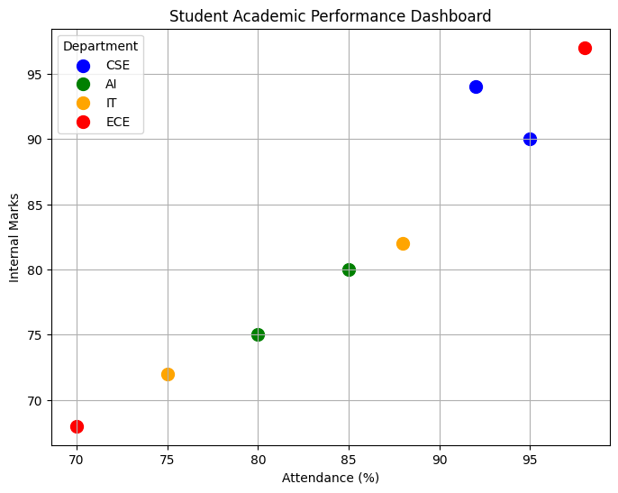

Scenario 2: Electric Vehicle Market Analysis
CODE:
import pandas as pd
import matplotlib.pyplot as plt
# Dataset
ev_data = pd.DataFrame({
'Vehicle Model':['Model A','Model B','Model C','Model D','Model E'],
'Battery Capacity':[40,50,60,75,90],
'Price':[800000,950000,1200000,1600000,2200000],
'Driving Range':[250,320,400,500,650],
'Manufacturer':['Tata','MG','Mahindra','Hyundai','BYD']
})
plt.figure(figsize=(8,6))
for company in ev_data['Manufacturer'].unique():
data = ev_data[ev_data['Manufacturer']==company]
plt.scatter(
data['Battery Capacity'],
data['Price'],
s=data['Driving Range'],
label=company,
alpha=0.7
)
plt.title("Electric Vehicle Market Analysis")
plt.xlabel("Battery Capacity (kWh)")
plt.ylabel("Price (₹)")
plt.legend(title="Manufacturer")
plt.grid(True)
plt.show()

OUTPUT:

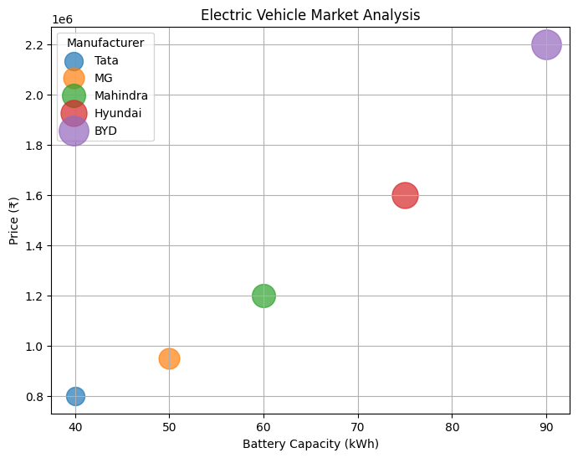

Scenario 3: Hospital Patient Admission Analysis
CODE:
import pandas as pd
import matplotlib.pyplot as plt
hospital_data = pd.DataFrame({
'Department':['Cardiology','Neurology','Orthopedics','Pediatrics','General'],
'Patients':[120,90,110,140,170],
'Treatment Cost':[50000,70000,45000,30000,25000]
})
plt.figure(figsize=(8,6))
bars = plt.bar(
hospital_data['Department'],
hospital_data['Patients'],
color=['red','blue','green','orange','purple']
)
for bar, cost in zip(bars, hospital_data['Treatment Cost']):
plt.text(
bar.get_x() + bar.get_width()/2,
bar.get_height() + 2,
str(cost),
ha='center'
)
plt.title("Hospital Patient Admission Analysis")
plt.xlabel("Department")
plt.ylabel("Number of Patients")
plt.show()

OUTPUT:
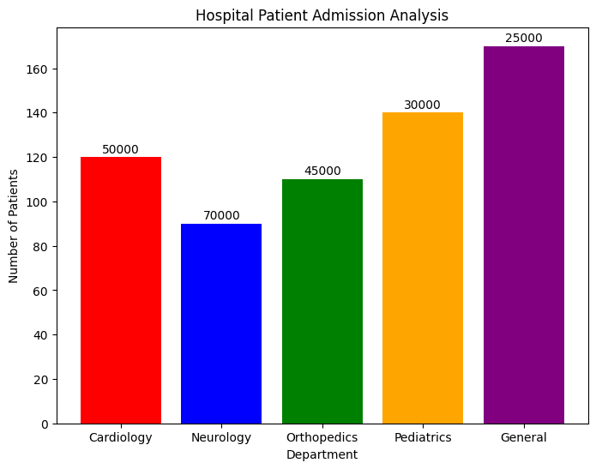

Scenario 4: Weather Monitoring System
CODE:
import pandas as pd
import matplotlib.pyplot as plt
weather = pd.DataFrame({
'Date':[1,2,3,4,5,6,7,8,9,10]*3,
'Temperature':[30,31,32,33,34,35,34,33,32,31,
28,29,30,31,32,33,32,31,30,29,
26,27,28,29,30,31,30,29,28,27],
'City':['Chennai']*10+['Hyderabad']*10+['Bangalore']*10
})

styles={'Chennai':'-','Hyderabad':'--','Bangalore':':'}
plt.figure(figsize=(8,5))
for city in weather['City'].unique():
d=weather[weather['City']==city]
plt.plot(d['Date'],d['Temperature'],
linestyle=styles[city],
label=city)
plt.title("Weather Monitoring System")
plt.xlabel("Date")
plt.ylabel("Temperature (°C)")
plt.legend()
plt.grid(True)
plt.show()

OUTPUT:
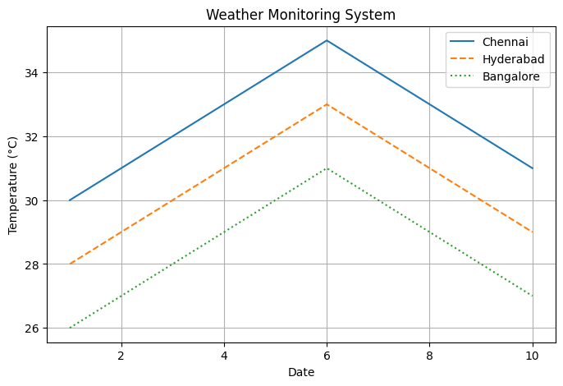

Scenario 5: Supermarket Sales Analysis
CODE:
import pandas as pd
import matplotlib.pyplot as plt
sales=pd.DataFrame({
'Category':['Grocery','Grocery','Electronics','Electronics','Clothing','Clothing'],
'Sales':[50000,45000,80000,70000,60000,55000],
'Branch':['A','B','A','B','A','B']
})
pivot=sales.pivot(index='Category',columns='Branch',values='Sales')
pivot.plot(kind='bar')
plt.title("Supermarket Sales Analysis")
plt.xlabel("Product Category")
plt.ylabel("Sales Amount")
plt.show()

OUTPUT:
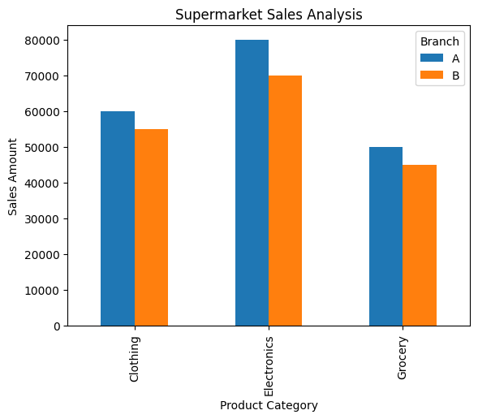

Scenario 6: Employee Salary Distribution
CODE:
import pandas as pd
import matplotlib.pyplot as plt
employee=pd.DataFrame({
'Salary':[25000,28000,30000,32000,35000,
38000,40000,42000,45000,47000,
50000,52000,55000,58000,60000]
})
plt.figure(figsize=(8,5))
plt.hist(employee['Salary'],
bins=6,
edgecolor='black')
plt.title("Employee Salary Distribution")
plt.xlabel("Salary")
plt.ylabel("Frequency")
plt.show()

OUTPUT:
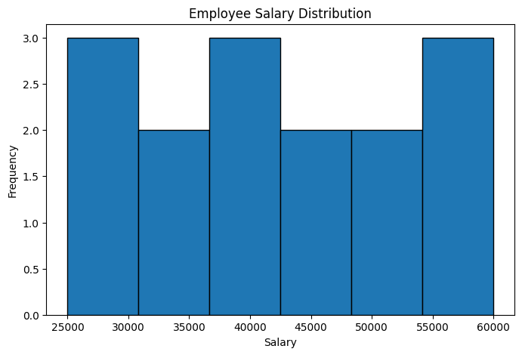
Scenario 7: Smartphone Market Comparison
CODE:
import pandas as pd
import matplotlib.pyplot as plt
phone=pd.DataFrame({
'Brand':['Samsung','Apple','OnePlus','Vivo','Xiaomi'],
'RAM':[6,8,12,8,16],
'ProcessorSpeed':[2.2,3.1,3.2,2.5,3.3],
'Price':[25000,80000,45000,28000,50000],
'Storage':[128,256,256,128,512]
})
markers={'Samsung':'o','Apple':'s','OnePlus':'^','Vivo':'D','Xiaomi':'*'}
plt.figure(figsize=(8,5))
for brand in phone['Brand'].unique():
d=phone[phone['Brand']==brand]
plt.scatter(d['RAM'],
d['Price'],
s=d['Storage'],
c=d['ProcessorSpeed'],
cmap='viridis',
marker=markers[brand],
label=brand)
plt.colorbar(label='Processor Speed')
plt.xlabel("RAM (GB)")
plt.ylabel("Price (₹)")
plt.title("Smartphone Market Comparison")
plt.legend()
plt.show()

OUTPUT:
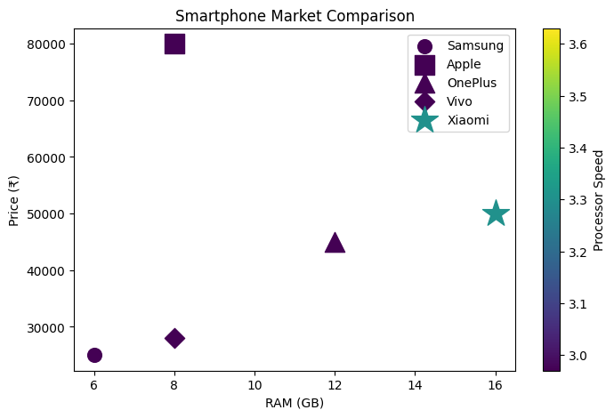
Scenario 8: Online Movie Rating Analysis
CODE:
import pandas as pd
import seaborn as sns
import matplotlib.pyplot as plt
movie=pd.DataFrame({
'Genre':['Action','Comedy','Drama','Horror','Sci-Fi'],
'Rating':[7.5,8.2,9.1,6.8,8.7],
'Year':[2020,2021,2022,2023,2024]
})
pivot=movie.pivot(index='Year',columns='Genre',values='Rating')
plt.figure(figsize=(8,5))
sns.heatmap(pivot,
annot=True,
cmap='YlOrRd')
plt.title("Online Movie Rating Analysis")
plt.show()

OUTPUT:
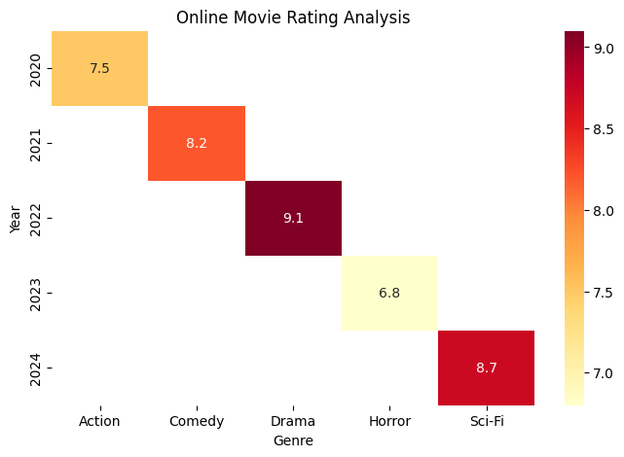

Scenario 9: COVID-19 State-wise Analysis
CODE:
import pandas as pd
import seaborn as sns
import matplotlib.pyplot as plt
covid=pd.DataFrame({
'State':['Tamil Nadu','Karnataka','Kerala','Maharashtra','Delhi'],
'Cases':[1200,800,1500,2000,700]
})
pivot=pd.DataFrame([covid['Cases'].values],
columns=covid['State'])
plt.figure(figsize=(8,2))
sns.heatmap(pivot,
annot=True,
cmap='Reds',
xticklabels=True,
yticklabels=False)
plt.title("COVID-19 State-wise Analysis")
plt.show()
OUTPUT:
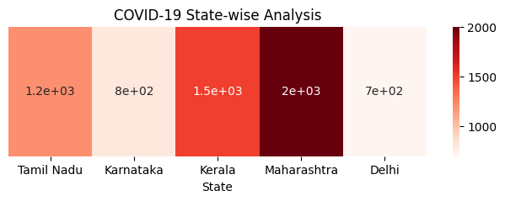
Scenario 10: Iris Flower Classification
CODE:
from sklearn.datasets import load_iris
import pandas as pd
import matplotlib.pyplot as plt
iris = load_iris(as_frame=True)
df = iris.frame
df['Species'] = df['target'].map({
0:'Setosa',
1:'Versicolor',
2:'Virginica'
})
markers = {
'Setosa':'o',
'Versicolor':'s',
'Virginica':'^'
}
plt.figure(figsize=(8,5))
for species in df['Species'].unique():
d = df[df['Species']==species]
plt.scatter(
d['sepal length (cm)'],
d['petal length (cm)'],
s=d['sepal width (cm)']*20,
label=species,
marker=markers[species]
)
plt.xlabel("Sepal Length")
plt.ylabel("Petal Length")
plt.title("Iris Flower Classification")
plt.legend()
plt.show()

OUTPUT:
